Marist College

Homework 0

Setting Up Java and GitHub

Hannah Youssef

Formal Languages and Computability

CMPT 440-111

Dr. Pablo Rivas

30 January 2019

Table of Contents

Java VM version screenshot 2

Java Compiler version screenshot 2

GitHub Account screenshot 3

GitHub class repository screenshot 4

GitHub class repository link 4

Proof of identity 5

# 

# Java VM version screenshot

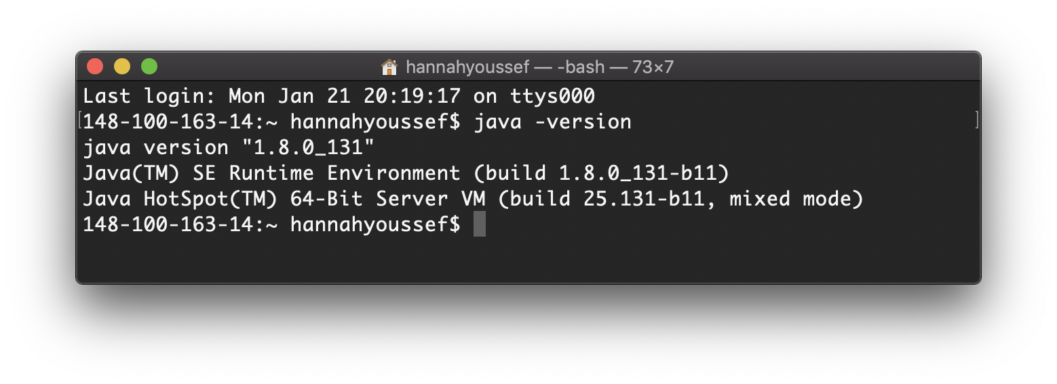

# 

# Java Compiler version screenshot

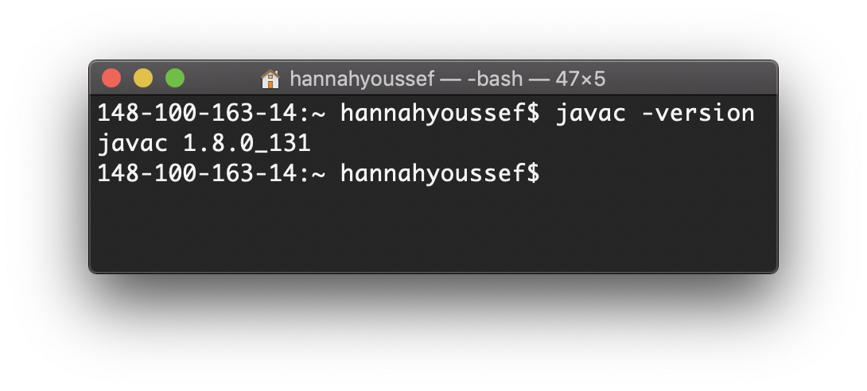

# GitHub Account screenshot

# GitHub class repository screenshot

# 

# GitHub class repository link

https://github.com/hannahyoussef/cmpt440youssef.git

# Proof of identity

(Apologies for the dirty laptop screen)